

PROJECT
WORK

2017

DEPARTMENT OF INFORMATION TECHNOLOGY

GOVERNMENT COLLEGE OF TECHNOLOGY
(An Autonomous Institution - Anna University)
COIMBATORE - 641 013
CLOUD ARMOR:SUPPORTING REPUTATION-BASED TRUST MANAGEMENT FOR PRIVATE CLOUD SERVICES

PROJECT SUBMITTED IN PARTIAL FULFILLMENT OF THE REQUIREMENTS FOR THE AWARD OF THE DEGREE OF BACHELOR OF TECHNOLOGY IN INFORMATION TECHNOLOGY
OF ANNA UNIVERSITY

Submitted by
ANAMIGA.S.V(1318102)

JAYACHITRA.R(1318119)
KIRUTHIKA.S(1318124)
ROJA.B(1318136)

Under the Guidance of
Mrs. R.DEVI, M.TECH, APIT.,

DEPARTMENT OF COMPUTER SCIENCE AND ENGINEERING
GOVERNMENT COLLEGE OF TECHNOLOGY
(An Autonomous Institution affiliated to Anna University Coimbatore)
COIMBATORE - 641 013

DEPARTMENT OF INFORMATION TECHNOLOGY
GOVERNMENT COLLEGE OF TECHNOLOGY
(An Autonomous Institution affiliated to Anna University )
COIMBATORE - 641 013

PROJECT WORK

APRIL 2017

This is to certify that this project work entitled

CLOUD ARMOR:SUPPORTING REPUTATION-BASED TRUST MANAGEMENT FOR PRIVATE
CLOUD SERVICES

is the bonafide record of project work done by

ANAMIGA S V 1318102
JAYACHITRA R 1318119
KIRUTHIKA S 1318124
ROJA B 1318136

of B.TECH. (Information Technology) during the year 2016 - 2017

Project Guide Head of the Department
Mrs. R.DEVI, M.TECH, APIT, DR.T.PURUSHOTHAMAN,PH.D

Submitted for the Project Viva-Voce examination held on ________________

Internal Examiner External Examiner

ACKNOWLEDGEMENT

Great achievements are not possible without standing on the shoulders of giants. Without the active involvement of the following experts this project would not have been a reality.

We express our sincere gratitude to Dr.S.Palanisamy ME., Ph.D., Principal, Government College of Technology, Coimbatore for providing us all facilities that we needed for the completion of this project.

We Whole-heartedly express our thankfulness and gratitude to DR.T.PurusothamanM.E.,Ph.D.,Professorand Head of the Department(Department of Information Technology) Government college of Technology, for helping us to successfully carry out this project.

Our thankfulness and gratitude to our respectable project guide Mrs.R.Devi, M.Tech., Assistant Professor, who has been immense help through the various phases of the project. With her potent ideas and excellent guidance we were able to comprehend the essential aspects involved. Her depth in the subject concerned is really profound and unbounded with which she has enlightened us incessantly and prevailed on us a rich source of inspiration. It is indeed a pleasure to work under her guidance.

We would like to thank our faculty advisor Thiru.S.Gladson Oliver, M.Tech., Assistant Professor for his continuous support and encouragement throughout this project.

We extend our sincere thanks to the staff members of InformationTechnologydepartmentTmt.C.AswiniM.E.,AssistantProfessor, Thiru.J.Kalidass,M.EAssistantProfessor,Tmt.M.BlessyQueenMary,M.TechAssistantProfessor,Tmt.T.Suguna M.Tech.,Assistant Professor,Tmt.R.Malavika M.Tech., Assistant Professor, Ms.M.JeyanthiM.Tech.,AssistantProfessor,for rendering their help for the completion of this project.

We also thank all the non-teaching staff for their support and to all our friends for their co-operation and suggestions towards the successful completion of this project.

SYNOPSIS

Trust management is one of the most challenging issues for the adoption and growth of cloud computing. There are several challenging issues in the trust management such as privacy, security, and availability. These process threatening the entire cloud users. In the New age communication cloud has been introduced. There are various services Available in the cloud server like (IaaS) – Infrastructure as a service, (PaaS)- Platform as a service, (SaaS) – Software as a service. From these services for security purpose (TaaS) – Trust as a service has been implemented.
In order to improve and overcome the Trust as a Service, various strategy has been implemented, they are follows:
Cloud E-Mail service that deals with the web application that manages the electronic way of communication. Through this project we can create our own cloud mail server with ESMTP – Enhanced Simple Mail Transfer Protocol.
The main aim is to create privacy preservation for the confidential database the proposed architecture implements the real world anonymous database by implementing the generalization and suppression. It deals with preventing malicious parties and intrusion using trust aware routing framework. The efficiency and security of data can be achieved by maintaining single database with specific access rights. With the action performed with IDS with ESMTP in Anonymous and Confidential Databases.

CONTENTS

CHAPTER NO. TITLE PAGENO.

BONAFIDE CERTIFICATE i

ACKNOWLEDGEMENT ii

SYNOPSIS iii

TABLE OF CONTENTS iv

LIST OF FIGURES v

- CHAPTER 1

1.1 INTRODUCTION
1 .2 PROBLEM DOMAIN
1.3 LITERATURE REVIEW
1.3.1 PRIVACY,TRUST AND SECURITY IN CLOUD COMPUTING
1.3.2 TRUST MECHANISMS FOR CLOUD COMPUTING
1.3.3 TOWARDS A TRUST MANAGEMENT SYSTEM FOR CLOUD COMPUTING
1.3.4 REPUTATION ATTACKS DETECTION FOR EFFECTIVE TRUST ASSESSMENT OF CLOUD SERVICES
1.3.5 TRUSTED CLOUD COMPUTNG WITH SECURE RESOURCES AND DATA COLOURING
1.4 BLOCK DIAGRAM
1.5 ORGANISATION OF PROJECT

- CHAPTER 2 11- 2.1 TRUST AWARE ROUTING PROCEDURE
2.1.1 ABOUT ROUTING PROCEDURE
2.1.2 TRUST AWARE ROUTING PROTOCOL
2.1.3 ABOUT SMTP
2.1.4 MAIL PROCESSING MODEL
2.1.5 PROTOCOL OVERVIEW

- CHAPTER 3 22-

3.1 ALGORITHM IMPLEMENTATION
3.2 OBJECTIVE OF THE PROJECT
3.3 IMPLEMENTED SYSTEM
3.4 PROJECT DESIGN
3.4.1 COMPANY ORGANIZATION ENVIRONMENT
3.4.2 CONFIGURING ESMTP
3.4.3 TRUST AS A SERVICE
3.4.4 IMPLEMENTING TRUST ROUTING FRAMEWORK
3.4.5 IMPLEMENTING AWARE ROUTINGFRAMEWORK
3.5 SYSTEM SPECIFICATION
3.5.1 APPLICATION SPECIFICATION
3.5.2 NETWORK SPECIFICATION
3..5.3 SOFTWARE SPECIFICATION

- CHAPTER 4 30-

4.1 IMPLEMENTATION
4.1.1 PSEUDOCODE
4.2 RESULTS

- CHAPTER 5 36-
5.1 CONCLUSION
5.2 FUTURE WORK
5.3 REFERENCES

LIST OF FIGURES

FIGURE NO FIGURE NAME PAGE NO

1.1 BLOCK DIAGRAM 11

2.1 MAIL PROCESSING MODEL 23

CHAPTER 1

1.1 INTRODUCTION:
Trust is a critical factor in cloud computing; in present practice it depends largely on perception of reputation, and self assessment by providers of cloud services. The advantages of cloud computing – its ability to scale rapidly, store data remotely, and share services in a dynamic environment – can become disadvantages in maintaining a level of assurance sufficient to sustain confidence in potential customers. The study of this problem has had a great impact to many organizations which can leverage such site-level knowledge to help an organization to adopt trust as a service.
We first give a brief introduction to the concept “TRUST AWARE ROUTING PROCEDURE” defined in this project, and then present the block diagram and methods currently developed to automatically mine the trust of a given organization and how effective trust as a service of an organization has a good impact on the trustworthiness of a particular employee.
  - PROBLEM DOMAIN:
Cloud computing has become a prominent paradigm of computing and IT service delivery. The issues and challenges of trust in cloud computing have been widely discussed from different perspectives. There is no specific application has been implemented for applying trust as a service. There are various drawbacks in finding out the malicious users. Identifying trust became more tedious in the existing system. No rules and algorithm has been implemented for identifying the trust users. No preservation of data has been implemented. These TMS nodes expose interfaces so that users can give their feedback or inquire the trust results in a decentralized way. But as mentioned above decentralize may minimize the trust ratio. The Only way to preserve privacy is to use cryptographic encryption techniques Also known as collusive malicious feedback behaviors, such attacks occur when several vicious users collaborate together to give numerous misleading feedbacks to increase the trust result of failures This paper addresses how to improveTrust as a service.. Specifically, we propose a model to improve the Trust as a service in an organization.
1.3 LITERATURE REVIEW:
So far, there are five different types of web sites structures typically used that are the popular yet experiencing a wide variety of problems. There are a lot of differences between the three and they are discussed in the following paragraphs.

1.3.1 PRIVACY,TRUST AND SECURITY IN CLOUD COMPUTING:
S. Pearson, “Privacy, Security and Trust in Cloud Computing,” in Privacy and Security for Cloud Computing, ser. Computer Communications and Networks, 2013,pp.3–42
Cloud computing refers to the underlying infrastructure for an emerging model of service provision that has the advantage of reducing cost by sharing computing and storage resources, combined with an on demand provisioning mechanism relying on a pay-per-use business model. These new features have a direct impact on information technology (IT) budgeting but also affect traditional security, trust and privacy mechanisms. The advantages of cloud computing – its ability to scale rapidly, store data remotely, and share services in a dynamic environment – can become disadvantages in maintaining a level of assurance sufficient to sustain confidence in potential customers. Some core traditional mechanisms for addressing privacy (such as model contracts) are no longer flexible or dynamic enough, so new approaches need to be developed to fit this new paradigm. In this chapter we assess how security, trust and privacy issues occur in the context of cloud computing and discuss ways in which they may be addressed. Although there is no definitive definition for cloud computing, a definition that is commonly accepted is provided by the United States National Institute of Standards and Technologies (NIST): This shared pool of resources is unified through virtualization or job scheduling techniques. Virtualization is the creation of a set of logical resources (whether it be a hardware platform, operating system, network resource or other resource) usually implemented by software components that act like physical resources. In particular, software called a ‘hypervisor’ emulates physical computer hardware and thus allows the operating system software running on the virtual platform — a virtual machine (VM) — to be separated from the underlying hardware resources. The resources made available through cloud computing include hardware and systems software on remote data centers, as well as services based upon these that are accessed through the Internet; these resources can be managed to dynamically scale up to match the load, using a pay-per resources business model. Key features advertised are elasticity, multi tenancy, maximal resource utilization and pay-per-use. These new features provide the means to leverage large infrastructures like data centers through virtualization or job management and resource management. Cloud computing (or, more simply, ‘cloud’) provides a market opportunity with a huge potential both for efficiency and new business opportunities (especially in service composition), and is almost certain to deeply transform our information technology infrastructures, models and services. Not only are there cost savings due to economies of scale on the service provider side and pay-as-you-go models, but business risk is decreased because there is less need to borrow money for upfront investment in infrastructure.
The adoption of cloud computing may move quite quickly depending on local requirements, business context and market specificities. We are still in the early stages but cloud technologies are becoming adopted widely in all parts of the world. The economic potential of cloud computing and its capacity to accelerate innovation are putting business and governments under increased pressure to adopt cloud computing based solutions. Although the hype around cloud tends to encourage people to think that it is a universal panacea, this is not the case and quite often promoters ignore the inherent complexities added by the cloud. There are a number of challenges to providing cloud computing services: the need to comply with local and regional regulations, obtaining the necessary approvals when data is accessed from another jurisdiction, some additional complexity in terms of governance, maintenance and liability inherent to cloud, and a perceived lack of trust in cloud services.

1.3.2 TRUST MECHANISMS FOR CLOUD COMPUTING:
J. Huang and D.M.Nicol, “Trust Mechanisms for Cloud Computing,” Journal of Cloud Computing, vol.2,no.1,pp.1–14,2013
Trust is a critical factor in cloud computing; in present practice it depends largely on perception of reputation, and self assessment by providers of cloud services. We begin this paper with a survey of existing mechanisms for establishing trust, and comment on their limitations. We then address those limitations by proposing more rigorous mechanisms based on evidence, attribute certification, and validation, and conclude by suggesting a framework for integrating various trust mechanisms together to reveal chains of trust in the cloud.
Cloud computing has become a prominent paradigm of computing and IT service delivery. Furthermore, what exactly does “trust” mean in the context of cloud computing? What is the basis of that trust? If the attributes of a cloud service (or a service provider) are used as evidence for trust judgment on the service (or provider respectively), on what basis should users believe the attributes claimed by cloud providers? Who are authorities to monitor, measure, assess, or validate cloud attributes? The answers to those questions are essential for wide adoption of cloud computing and for cloud computing to evolve into a trustworthy computing paradigm. As addressed in, “the growing importance of cloud computing makes it increasingly imperative that we grapple with the meaning of trust in the cloud and how the customer, provider, and society in general establish that trust.” The issues and challenges of trust in cloud computing have been widely discussed from different perspectives. A number of models and tools have been proposed. Each contributes a partial view of cloud trust, but lacking still is a complete picture illustrating how cloud entities work together to form a “societal” system, with a solid grounding in trust, serving to facilitate trusted paths to trusted cloud services. The NIST Cloud Computing Reference Architecture identified cloud brokers and cloud auditors as entities who conduct assessment of cloud services; however, there are few studies on trust relation analysis and the chains of trust from cloud users to cloud services (or providers) through those intermediary cloud entities. In this paper, we investigate trust mechanisms for the cloud, present our vision of the “societal systems mechanisms” of trust and a framework for analyzing trust relations in the cloud, and suggest trust mechanisms which combine attribute certification, evidence-based trust and policy-based trust.
Because of the criticality of many computing services and tasks, some cloud clients cannot make decisions about employing a cloud service based solely on informal trust mechanisms (e.g. web-based reputation scores); these decisions need to be based on formal trust mechanisms, which are more certain, more accountable, and more dependable. Here, the word “formal” is meant to carry the sense of “official” assessment in a society. In our suggested cloud trust mechanisms, the attributes of a cloud service (or its provider) are used as evidence for the user’s trust judgment on the service (or provider), and the belief in those attributes is based on “formal” certification and chains of trust for validation.

1.3.3 TOWARDS A TRUST MANAGEMENT SYSTEM FOR CLOUD COMPUTING:
S.Habib, S.Ries, and M.Muhlhauser, “Towards a Trust Management System for Cloud Computing,” in Proc.of TrustCom’11, 2011
Cloud computing provides cost-efficient opportunities for enterprises by offering a variety of dynamic, scalable, and shared services. Usually, cloud providers provide assurances by specifying technical and functional descriptions in Service Level Agreements (SLAs) for the services they offer. The descriptions in SLAs are not consistent among the cloud providers even though they offer services with similar functionality. Therefore, customers are not sure whether they can identify a trustworthy cloud provider only based on its SLA. To support the customers in reliably identifying trustworthy cloud providers, we propose a multi-faceted Trust Management (TM) system architecture for a cloud computing marketplace. This system provides means to identify the trustworthy cloud providers in terms of different attributes (e.g., security, performance, compliance) assessed by multiple sources and roots of trust information
Cloud computing offers dynamic, scalable, shared resources (e.g., computing power, storage, software) over the internet from remote data centres to the users (e.g., business organizations, government authorities, individuals). The highly distributed and non-transparent nature of cloud computing represents a considerable obstacle for the acceptance and market success of cloud services. Potential customers of these services often feel that they lose the control over their data, and they are not sure whether they can trust the cloud providers. A recent survey, conducted among more than 3000 cloud consumers from 6 countries, shows that 84% of the consumers are concerned about their data storage location and 88% of the consumers worry about who has access to their data.
Consumer concerns can be mitigated by using preventive measures for privacy (e.g., demonstrating compliance standards) and security (e.g., secure hypervisors, TPM based servers). At present, although cloud providers demonstrate their preventive measures by including related descriptions in the SLAs, assurances and compensations for SLA violations are not convincing enough for the consumers. Especially, SLAs with vague clauses and unclear technical specifications lead the consumers into a decision dilemma when considering them as the only basis to identify trustworthy providers.
As the business market is growing rapidly with new providers entering the market, cloud providers will increasingly compete for customers by providing services with similar functionality. However, there can be huge differences regarding the provided quality level of those services. Such a competitive market needs means to reliably assess the quality level of the service providers. Trust and reputation (TR) systems are successfully used in numerous application scenarios to support users in identifying the reliable and trustworthy providers, e.g., on eBay, Amazon, and app markets for mobile applications. Similar approaches are needed to support customers in selecting appropriate trustworthy cloud providers.
Existing TR systems rely on customer feedback without considering other sources and roots of information (e.g., property certificates, compliance with audit standards, provider statements). Moreover, there are additional parameters that are required to support the customers in selecting providers in a cloud marketplace. Therefore, TR systems have to evolve into Trust Management (TM) systems – as defined in – to support the customers in making transparent assessments before selecting reliable trustworthy cloud providers

1.3.4 REPUTATION ATTACKS DETECTION FOR EFFECTIVE TRUST ASSESSMENT OF CLOUD SERVICES:
T.H.Noor, Q.Z.Sheng, and A.Alfazi, “Reputation Attacks Detection for Effective Trust Assessment of Cloud Services,” in Proc.of TrustCom’13, 2013
Consumers’ feedback is a good source to help assess overall trustworthiness of cloud services. However, it is not unusual that a trust management system experiences malicious behaviors from its users (i.e., collusion or Sybil attacks). In this paper, we propose techniques for the detection of reputation attacks to allow consumers to effectively identify trustworthy cloud services. We introduce a credibility model that not only identifies misleading trust feedbacks from collusion attacks but also detects Sybil attacks, either strategic (in a long period of time) or occasional (in a short period of time). We have collected a large collection of consumer’s trust feedbacks given on real-world cloud services (over 10,000 records) to evaluate and demonstrate the applicability of our approach and show the capability of detecting such malicious behaviours.
Due to highly dynamic, distributed and non-transparent nature of cloud services, trust management is considered as a challenging problem in cloud environments. SLAs alone are inadequate to establish trust between cloud consumers and providers because of its unclear and inconsistent clauses. For instance, in a recent survey, 46.6% of consumers agree that SLA’s legal contents are unclear. Many researchers agree that consumers’ feedback is a good source to assess trust and proposed trust management techniques based on feedback. However, in reality, it is not unusual that a trust management service experiences malicious behaviors (e.g., collusion or Sybil attacks) from its users. Attackers can trick users into trusting untrustworthy cloud services through creating several accounts, producing numerous transactions (e.g., creating multiple virtual machines for a short period of time), and leaving misleading trust feedbacks. Such manipulation makes it hard for consumers to identify trustworthy providers.
This paper focuses on the detection of reputation attacks to allow consumers to effectively identify trustworthy cloud services. The detection of reputation attacks involves several issues including i) Consumers Dynamism where new users join the cloud environment and old users leave around the clock which makes the detection of feedback collusion a significant challenge, ii) Multiplicity of Identities where users may have multiple accounts for a particular cloud service1 which makes it difficult to detect whether a Sybil attack is performed because multiple identities can be used to give misleading information, iii) Attackers Behaviors where it is difficult to predict when such malicious behaviors take place either in a long or short period of time (i.e., strategic vs. occasional behaviors) iv) Consumers’ Privacy where the detection of attacks can make users subject to privacy breaches especially when the interactions involve sensitive information.
In this paper, we overview the design and the implementation of a credibility model that allows consumers to effectively identify trustworthy cloud services. Our model exploits novel techniques that help detect collusion and Sybil attacks without breaching consumers’ privacy. In a nutshell, the salient features of our model are i) Zero-Knowledge Credibility Proof Protocol that enables the trust management service to prove the credibility of consumers’ feedback without breaching consumers’ privacy (i.e., without the use of sensitive information); ii) Collusion Attacks Detection where we propose several detection metrics including the Feedback Density and Occasional Feedback Collusion to distinguish between misleading and credible feedbacks no matter attacks occur in a strategic or occasional behavior (i.e., attackers who intend to manipulate the trust results by giving multiple feedbacks to a certain cloud service in a long or short period of time); iii) Sybil Attacks Detection where we propose several metrics for the Sybil attacks detection including the Multi-Identity Recognition and Occasional Sybil Attacks to identify misleading feedbacks from Sybil attacks that occur strategically or occasionally (i.e., attackers who create multiple identities and give feedbacks in a short or long period of time to trick consumers into trusting cloud services that are not trustworthy).

1.3.5 TRUSTED CLOUD COMPUTNG WITH SECURE RESOURCES AND DATA COLOURING:
K.Hwang and D.Li, “Trusted Cloud Computing with Secure Resources and Data Coloring,” IEEE Internet Computing, vol.14, no.5,pp.14–22,2010
Trust and security have prevented businesses from fully accepting cloud platforms. To protect clouds, providers must first secure virtualized data centre resources, uphold user privacy, and preserve data integrity. The authors suggest using a trust-overlay network over multiple data centers to implement a reputation system for establishing trust between service providers and data owners. Data coloring and software watermarking techniques protect shared data objects and massively distributed software modules. These techniques safeguard multi-way authentications, enable single sign-on in the cloud, and tighten access control for sensitive data in both public and private clouds.
Cloud computing enables a new business model that supports on demand, pay-for-use, and economies-of-scale IT services over the Internet. The Internet cloud works as a service factory built around virtualized data centers. Cloud platforms are dynamically built through virtualization with provisioned hardware, software, networks, and datasets. The idea is to migrate desktop computing to a service oriented platform using virtual server clusters at data centers. However, a lack of trust between cloud users and providers has hindered the universal acceptance of clouds as outsourced computing services. To promote multi tenancy, we must design the cloud ecosystem to be secure, trustworthy, and dependable.
In reality, trust is a social problem, not a purely technical issue. However, we believe that technology can enhance trust, justice, reputation, credibility, and assurance in Internet applications. To increase the adoption of Web and cloud services, cloud service providers (CSPs) must first establish trust and security to alleviate the worries of a large number of users. A healthy cloud ecosystem should be free from abuses, violence, cheating, hacking, viruses, rumors, pornography, spam, and privacy and copyright violations. Both public and private clouds demand “trusted zones” for data, virtual machines (VMs), and user identity, as VMware and EMC 3 originally introduced.
Data integrity issues in the cloud differ from those in traditional database systems. Cloud users are most concerned about whether data-centre owners will abuse the system by randomly using private datasets or releasing sensitive data to a third party without authorization. Cloud security hinges on how to establish trust between these service providers and data owners. To address these issues, we propose a reputation-based trust-management scheme augmented with data coloring and software watermarking. Information about related trust models is available elsewhere.
The Cloud Security Alliance has identified a few critical issues for trusted cloud computing, and several recent works discuss general issues on cloud security and privacy. Public and private clouds demand different levels of security enforcement. We can distinguish among different service-level agreements (SLAs) by their variable degree of shared responsibility between cloud providers and users. Critical security issues include data integrity, user confidentiality, and trust among providers, individual users, and user groups. The infrastructure-as-a-service (IaaS) model sits at the innermost implementation layer, which is extended to form the platform-as-a service (PaaS) layer by adding OS and middleware support. PaaS further extends to the software-as-a-service (SaaS) model by creating applications on data, content, and metadata using special APIs. This implies that SaaS demands all protection functions at all levels. At the other extreme, IaaS demands protection mainly at the networking, trusted computing, and compute/storage levels, whereas PaaS embodies the IaaS support plus additional protection at the resource-management level.

1.4 BLOCK DIAGRAM:
The primary idea of the similarity matching scheme for spam detection is to maintain a known spam database, formed by user feedback, to block subsequent near-duplicate spams. On purpose of achieving efficient similarity matching and reducing storage utilization, prior works mainly represent each e-mail by a succinct abstraction derived from e-mail content text. However, these abstractions of e-mails cannot fully catch the evolving nature of spasm, and are thus not effective enough in near-duplicate detection. In this paper, we propose a novel e-mail abstraction scheme, which considers e-mail layout structure to represent e-mails. We present a procedure to generate the e-mail abstraction using HTML content in e-mail, and this newly devised abstraction can more effectively capture the near-duplicate phenomenon of spasm. Moreover, we design a complete spam detection system Codes (standing for Collaborative Spam Detection System), which possesses an efficient near-duplicate matching scheme and a progressive update scheme. The progressive update scheme enables system Codes to keep the most up-to-date information for near-duplicate detection. We evaluate Codes on a live data set collected from a real e-mail server and show that our system outperforms the prior approaches in detection results and is applicable to the real world.

.

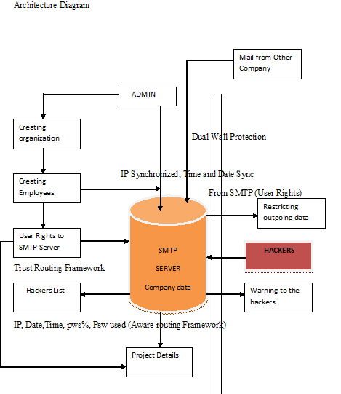

1.5 ORGANISATION OF THE PROJECT
The thesis is organized in the following way,
Chapter 2 deals with the Trust Aware Routing Procedure – giving a clear idea of what it is and its uses – Trust aware routing protocol – About SMTP- Mail processing model.
Chapter 3 pictures the design of the project in steps – Company Organization Environment–Configuring ESMTP–Trust As a Service– Implementing Trust Routing Procedure – Implementing Aware Routing Procedure.
Chapter 4 shows the implementation of the project having the phases as mentioned in the above chapter. It also helps us to visualize the results of the project implementation and to compare and contrast the results of the techniques implemented.
Chapter 5 concludes our work and leads to the future work.

CHAPTER 2

2.1 TRUST AWARE ROUTING PROCEDURE

2.1.1 ABOUT ROUTING PROCEDURE:
Security is a critical issue in a mobile ad hoc network (MANET). In most of the previous protocols security is an added layer above the routing protocol. We propose a Trust Aware Routing Protocol (TARP) for secure-trusted routing in mobile ad hoc networks. In TARP, security is inherently built into the routing protocol where each node evaluates the trust level of its neighbors based on a set of attributes and determines the route based on these attributes.
This paper evaluates the proposed TARP protocols on two important attributes, the battery power and the software configuration. A secure route between a source and destination is established based on a confidence level prescribed by a user or application in terms of these attributes. Our performance evaluation shows that TARP is a robust and adaptive trust routing algorithm that reacts quickly and effectively to the dynamics of the network while still finding the shortest path to the destination. TARP is able to improve security and at the same time reduce the total routing traffic sent and received in the network by directing the traffic based on the requested sender attributes

2.1.2 TRUST AWARE ROUTING PROTOCOL:
TARP selects routes to the destination based not only on the shortest path but also on several other security oriented attributes of the nodes. Only nodes that match the sender requirements would forward the packet.
The main objectives of the proposed TARP suite are:
(a) Implement security that is inherently built into the routing protocol
(b) Deliver messages that are received with a user defined or best available level of confidence
(c) Allow users and applications to prescribe their required level of security
(d) Achieve efficiency in routing that is improved by limiting control message exchanges
(e) optimize resource usage
(f) Obtain graceful network performance degradation
(g) develop a protocol suite that adapts to changes in the environment, such as the network topology, the power-level of nodes, etc.
In TARP, the security parameters considered in computing the trust-level of a node in a given route include: software configuration, hardware configuration, battery power, credit history, exposure and organizational hierarchy. Each node evaluates the trust level of its neighbors based on the above parameters and includes it in computing the next hop node in the overall shortest route computation. Due to page limitations, this paper will focus on the implementation and evaluation of the battery power and the software configuration attributes. Below is a description of the battery power and software configuration attributes:
- POWER:
In wireless networks, the battery power with which nodes operate is a limited resource. Each node uses its power to not only send and receive, it also behaves as a router by forwarding routing messages and updates. The cryptographic techniques that provide security are computationally intensive, which further increase the power consumption of a node. The node's trust level should be set to low since it cannot guarantee its service. This illustrates that power is an important parameter for evaluating the trust level of a node.
- SOFTWARE CONFIGURATION:
The software configuration includes the encryption ability of a node. To satisfy CAI (Confidentiality, Availability and Integrity), different cryptographic mechanisms have been proposed. Some are based on symmetric encryption and others on asymmetric encryption. Each node is given either a shared secret key or a public/private key pair depending on the type of cryptographic mechanism. Different encryption algorithms are available such as RSA, DES/3DES, BLOWFISH, IDEA, SEAL RC2/RC4/RC5/RC6 [12]. Strong encryption is often discerned by the key length used by the algorithm. In general, a node with a stronger encryption algorithm has a higher trust level than a node with a weaker encryption algorithm.

2.1.3 ABOUT SMTP:
The Simple Mail Transfer Protocol (SMTP) service provided by IIS is a simple component for delivering outgoing e-mail messages. Delivery of a message is initiated by transferring the message to a designated SMTP server. Based on the domain name of the recipient e-mail address, the SMTP server initiates communications with a Domain Name System (DNS) server, which looks up and then returns the host name of the destination SMTP server for that domain.
Next, the originating SMTP server communicates with the destination SMTP server directly through Transmission Control Protocol/Internet Protocol (TCP/IP) on port 25. If the user name of the recipient e-mail address matches one of the authorized user accounts on the destination server, the original e-mail message is transferred to that server, waiting for the recipient to pick up the message through a client program.
In the case where the originating SMTP server cannot communicate directly with the destination server, the SMTP service can transfer messages through one or more intermediate relay SMTP servers. A relay server receives the original message and then delivers it to the destination server, or redirects it to another relay server. This process is repeated until the message is delivered or a designated timeout period passes.
The SMTP service is not installed by default. You must install the SMTP service using the Control Panel. Installing the SMTP service creates a default SMTP configuration which you can then customize to your needs using IIS Manager.

2.1.3.1 SMTP VS MAIL RETREIVAL:
SMTP is a delivery protocol only. It cannot pull messages from a remote server on demand. Other protocols, such as the Post Office Protocol (POP) and the Internet Message Access Protocol (IMAP) are specifically designed for retrieving messages and managing mail boxes. However, SMTP has a feature to initiate mail queue processing on a remote server so that the requesting system may receive any messages destined for it (see Remote Message Queue Starting below). POP and IMAP are preferred protocols when a user's personal computer is only intermittently powered up, or Internet connectivity is only transient and hosts cannot receive message during off-line periods. Remote Message Queue Starting is a feature of SMTP that permits a remote host to start processing of the mail queue on a server so it may receive messages destined to it by sending the TURN command. This feature however was deemed insecure[15] and was extended in RFC 1985 with the ETRN command which operates more securely using an authentication method based on Domain Name System information.

2.1.3.2 OUTGOING MAIL SMTP SERVER:
An e-mail client needs to know the IP address of an SMTP server and this has to be given as part of its configuration (usually given as a DNS name). The server will deliver outgoing messages on behalf of the user.

2.1.3.3 OUTGOING MAIL SERVER ACCESS RESTRICTIONS:
Server administrators need to impose some control on which clients can use the server. This enables them to deal with abuse, for example spam. Two solutions have been in common use:
- In the past, many systems imposed usage restrictions by the location of the client, only permitting usage by clients whose IP address is one that the server administrators control. Usage from any other client IP address is disallowed.
- Modern SMTP servers typically offer an alternative system that requires authentication of clients by credentials before allowing access.

2.1.3.4 RESTRICTING ACCESS BY LOCATION:
Under this system, an ISP's SMTP server will not allow access by users who are 'outside the ISP's network'. More precisely, the server may only allow access to users with an IP address provided by the ISP, which is equivalent to requiring that they are connected to the Internet using that same ISP. A mobile user may often be on a network other than that of their normal ISP, and will then find that sending email fails because the configured SMTP server choice is no longer accessible.
This system has several variations. For example, an organisation's SMTP server may only provide service to users on the same network, enforcing this by firewalling to block access by users on the wider Internet. Or the server may perform range checks on the client's IP address. These methods were typically used by corporations and institutions such as universities which provided an SMTP server for outbound mail only for use internally within the organisation. However, most of these bodies now use client authentication methods, as described below.
By restricting access to certain IP addresses, server administrators can readily recognize the IP address of any abuser. As it will be a meaningful address to them, the administrators can deal with the rogue machine or user.
Where a user is mobile, and may use different ISPs to connect to the internet, this kind of usage restriction is onerous, and altering the configured outbound email SMTP server address is impractical. It is highly desirable to be able to use email client configuration information that does not need to change.

2.1.3.5 CLIENT AUTHENTICATION:
Modern SMTP servers typically require authentication of clients by credentials before allowing access, rather than restricting access by location as described earlier. This more flexible system is friendly to mobile users and allows them to have a fixed choice of configured outbound SMTP server.

2.1.4 MAIL PROCESSING MODEL:
Email is submitted by a mail client (MUA, mail user agent) to a mail server (MSA, mail submission agent) using SMTP on TCP port 587. Most mailbox providers still allow submission on traditional port 25. From there, the MSA delivers the mail to its mail transfer agent (MTA, mail transfer agent). Often, these two agents are just different instances of the same software launched with different options on the same machine. Local processing can be done either on a single machine, or split among various appliances; in the former case, involved processes can share files; in the latter case, SMTP is used to transfer the message internally, with each host configured to use the next appliance as a smart host. Each process is an MTA in its own right; that is, an SMTP server.
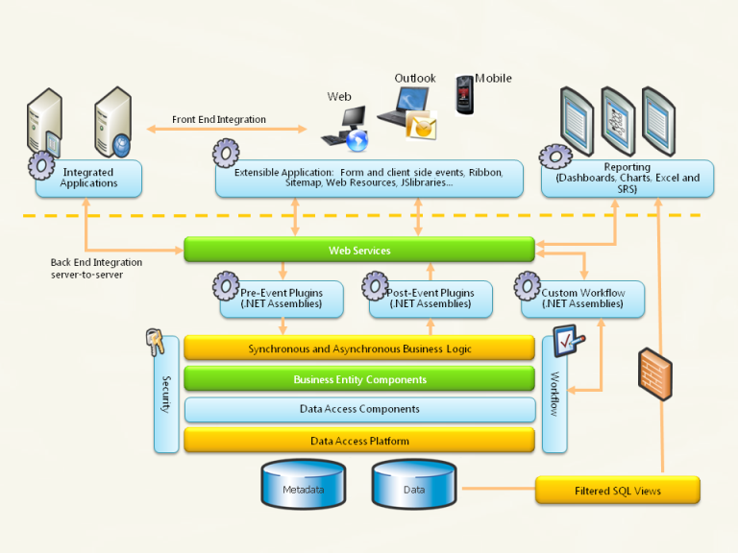
The boundary MTA has to locate the target host. It uses the Domain name system (DNS) to look up the mail exchanger record (MX record) for the recipient's domain (the part of the address on the right of @). The returned MX record contains the name of the target host. The MTA next connects to the exchange server as an SMTP client. (The article on MX record discusses many factors in determining which server the sending MTA connects to.)
Once the MX target accepts the incoming message, it hands it to a mail delivery agent (MDA) for local mail delivery. An MDA is able to save messages in the relevant mailbox format. Again, mail reception can be done using many computers or just one —the picture displays two nearby boxes in either case. An MDA may deliver messages directly to storage, or forward them over a network using SMTP, or any other means, including the Local Mail Transfer Protocol (LMTP), a derivative of SMTP designed for this purpose.
Once delivered to the local mail server, the mail is stored for batch retrieval by authenticated mail clients (MUAs). Mail is retrieved by end-user applications, called email clients, using Internet Message Access Protocol (IMAP), a protocol that both facilitates access to mail and manages stored mail, or the Post Office Protocol (POP) which typically uses the traditional mbox mail file format or a proprietary system such as Microsoft Exchange/Outlook or Lotus Notes/Domino. Webmail clients may use either method, but the retrieval protocol is often not a formal standard.
SMTP defines message transport, not the message content. Thus, it defines the mail envelope and its parameters, such as the envelope sender, but not the header or the body of the message itself. STD 10 and RFC 5321 define SMTP (the envelope), while STD 11 and RFC 5322 define the message (header and body), formally referred to as the Internet Message Format.

2.1.5 PROTOCOL OVERVIEW:
SMTP is a connection-oriented, text-based protocol in which a mail sender communicates with a mail receiver by issuing command strings and supplying necessary data over a reliable ordered data stream channel, typically a Transmission Control Protocol (TCP) connection. An SMTP session consists of commands originated by an SMTP client (the initiating agent, sender, or transmitter) and corresponding responses from the SMTP server (the listening agent, or receiver) so that the session is opened, and session parameters are exchanged. A session may include zero or more SMTP transactions. An SMTP transaction consists of three command/reply sequences (see example below.) They are:
MAIL command, to establish the return address . This is the address for bounce messages.
RCPT command, to establish a recipient of this message. This command can be issued multiple times, one for each recipient. These addresses are also part of the envelope.
DATA to send the message text. This is the content of the message, as opposed to its envelope. It consists of a message header and a message body separated by an empty line.
DATA is actually a group of commands, and the server replies twice: once to the DATA command proper, to acknowledge that it is ready to receive the text, and the second time after the end-of-data sequence, to either accept or reject the entire message.
Besides the intermediate reply for DATA, each server's reply can be either positive (2xx reply codes) or negative. Negative replies can be permanent (5xx codes) or transient (4xx codes). A reject is a permanent failure by an SMTP server; in this case the SMTP client should send a bounce message. A drop is a positive response followed by message discard rather than delivery.
The initiating host, the SMTP client, can be either an end-user's email client, functionally identified as a mail user agent (MUA), or a relay server's mail transfer agent (MTA), that is an SMTP server acting as an SMTP client, in the relevant session, in order to relay mail. Fully capable SMTP servers maintain queues of messages for retrying message transmissions that resulted in transient failures.
A MUA knows the outgoing mail SMTP server from its configuration. An SMTP server acting as client, i.e. relaying, typically determines which SMTP server to connect to by looking up the MX (Mail exchange) DNS resource record for each recipient's domain name. Conformant MTAs (not all) fall back to a simple A record in case no MX record can be found. Relaying servers can also be configured to use a smart host.
An SMTP server acting as client initiates a TCP connection to the server on the "well-known port" designated for SMTP: port 25. MUAs should use port 587 to connect to an MSA. The main difference between an MTA and an MSA is that SMTP Authentication is mandatory for the latter only.

CHAPTER 3

3.1 ALGORITHM IMPLEMENTATION:
Assume that a hash function selects each array position with equal probability. If m is the number of bits in the array, and k is the number of hash functions, then the probability that a certain bit is not set to 1 by a certain hash function during the insertion of an element is then
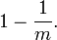
The probability that it is not set to 1 by any of the hash functions is
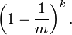
If we have inserted n elements, the probability that a certain bit is still 0 is
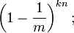
the probability that it is 1 is therefore
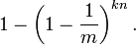
Now test membership of an element that is not in the set. Each of the k array positions computed by the hash functions is 1 with a probability as above. The probability of all of them being 1, which would cause the algorithm to erroneously claim that the element is in the set, is often given as
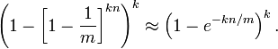
This is not strictly correct as it assumes independence for the probabilities of each bit being set. However, assuming it is a close approximation we have that the probability of false positives decreases as m (the number of bits in the array) increases, and increases as n (the number of inserted elements) increases. For a given m and n, the value of k (the number of hash functions) that minimizes the probability is
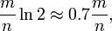
which gives the false positive probability of
The required number of bits m, given n (the number of inserted elements) and a desired false positive probability p (and assuming the optimal value of k is used) can be computed by substituting the optimal value of k in the probability expression above:
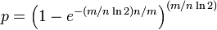
which can be simplified to:
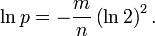
This results in:
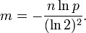
This means that for a given false positive probability p, the length of a Bloom filter m is proportionate to the number of elements being filtered n.^{[2]} While the above formula is asymptotic (i.e. applicable as m,n → ∞), the agreement with finite values of m,n is also quite good; the false positive probability for a finite bloom filter with m bits, n elements, and k hash functions is at most
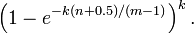
So we can use the asymptotic formula if we pay a penalty for at most half an extra element and at most one fewer bit.

3.2 OBJECTIVE OF THE PROJECT:
The Primary objective of this project is to develop a trust aware routing environment using ESMTP server. Here an email environment is developed for an organization; trust is implemented for user rights as well as aware routing is implemented for security purpose. For special security purpose here we introducing a latest method called as IDS (Instruction detection system), which identified the third party intruder or hacker from other networks. The basic IDS can able capture the ip details, here we using a advanced IDS method which can able to capture ip address of the hacker, data, time and the password which he tries to hack. In added with the trust method will provide the user rights within the organization.

3.3 IMPLEMENTED SYSTEM:
In the proposed system an organization environment has been used for implementing both trust and aware framework. Here SMTP server has been enhanced as ESMTP for implementation of Trust as a service and IDS has been implemented for Aware as a service. The Enhanced Simple Mail Transfer Protocol (ESMTP) service provided by IIS(Internet Information Service) is a component for delivering outgoing e-mail messages for a DNS(Domain Name server) based SMTP. Delivery of a message is initiated by transferring the message to a designated ESMTP server. Based on the domain name of the recipient e-mail address, the SMTP server initiates communications with a Domain Name System (DNS) server, which looks up and then returns the host name of the destination SMTP server for that domain.
The ESMTP is a flexible mail server which can be implemented in various environments like IT Organizations, Private Organization, Government sectors and etc. And ESTMP can be customized more up to the user favor. This protocol supports multiple file types, various security levels, multiple organization and etc. All these techniques come under a single architecture. As per existing the cloud armor deals with customer feedback in a public cloud. According to the activity of the users, the trustworthiness of the user or customer will be evaluated.
Here the trust as a service has been modified according to trust routing framework. The ESMTP has been customized according to the admin procedure. So that admin can provide user rights to the employee by customizing the mail components like compose, inbox, send items and etc. The customized mail server will reflect to the users login and mail will response for unidirectional. For Aware routing framework, intrusion detection has been implemented. The IDS will capture all the intruders’ details like data, time, IP address, Password used, Password matching percentage and times of hacking. This makes the admin more secure from the intruder and hacker side. And finally the color code has been implemented for secured login. For color code quantum cryptography has been used. A color grid is available with various colors. User can select any three colors for secured login. In added with Gaussian mixture and keystroke has been implemented for pattern based password login.

3.4 PROJECT DESIGN:

The project is divided into 5 parts:-

- Creating Cloud Organization Environment
- Configuring ESMTP
- Trust as a Service
- Implementing Trust routing framework – For Privacy
- Implementing Aware routing framework – For Preservation

3.5 COMPANY ORGANIZATION ENVIRONMENT:
This is the initial module of this project. It consists of creating a cloud based organization for the trust aware routing framework procedure. This can be done by web based centralization and other basic details of the company will be provided. This module is only enabled for admin those who creates the company. While creating company all the basic company details should be entered, along with the DNS and ID of the mail server.

3.6 CONFIGURING ESMTP:
Here users are the configuring components of the ESMTP. This is because the object of this thesis to protect the ESMTP by the dual wall protection methods. Here the organization admin can create various users for their company, as well as they can able to share the group mails inside the group of companies. These mails will not be stored in the junk mails, because these all are confidential mails handling in the ESMTP architecture. Whenever the organization is created the default ESMTP will be assigned for both user and the company. The default company DNS will be in xxxx@companyname.com and the default user name in the DNS will be username@companyname.com.

3.7 TRUST AS A SERVICE :
This is the core module in this project. Here the system will be comes under a security zone for user monitoring. There are three types of trust methods are used in this module namely IP synchronization, Data Synchronization and Time Synchronization. As mentioned above these process will generate warning to the admin in case of any misbehaving activates of the employee. This method will increase the trust level of the employee between the companies. On time monitoring methods will be used here.

3.8 IMPLEMENTING TRUST ROUTING FRAMEWORK - FOR PRIVACY:
In order to implement the trust routing framework, customized SMTP is needed. So that here customization options of the ESMTP server will take place for providing the user rights. After creating the user by the admin, admin can provide customized user rights to the users. The customizations are customizing compose option, inbox, outbox, sent items and etc. So from the methods the users can be categorized as well as the prior user of the mail server will not be responsible for any other problem. These rights can be given to all the users of this mail server.

3.9 IMPLEMENTING AWARE ROUTING FRAMEWORK –FOR PRESERVTION:
In order to implement the aware routing framework here we are introducing IDS (Instruction detection system). An intrusion detection system (IDS) is a device or software application that monitors network or system activities for malicious activities or policy violations and produces reports to a management station. Some systems may attempt to stop an intrusion attempt but this is neither required nor expected of a monitoring system. Intrusion detection and prevention systems (IDPS) are primarily focused on identifying possible incidents, logging information about them, and reporting attempts. In addition, organizations use IDPSes for other purposes, such as identifying problems with security policies, documenting existing threats and deterring individuals from violating security policies. IPSec have become a necessary addition to the security infrastructure of nearly every organization. The intrusion detection will capture the unauthorized user’s details like ip address, password used for hacking, Data and time of hacking, Password matching percentage. So the user can identify who is the other intruding into the network. So that user can identify the hackers easily through their ip address.

3.10 SYSTEM SPECIFICATION:
3.10.1 APPLICATION SPECIFICATION:
CLIENT/SERVER ARCHITECTURE:
Benefits offered by client/server architecture:
- Increased user communication because of flexible data access.
- Highly interactive user interface.
- Increased developer productivity through usage of easy to use easy tools.
- Improved access to information because of networking.
- Better control of corporate data through centralized data, systems & network management.
- Easier maintenance of application & data.
- Protection of hardware investments by making use of existing installations of Hardware, software & network and at same time getting maximum leverage out of the available desktop technology.

3.10.2 NETWORK SPECIFICATION:
This thesis is purely developed for multi user system and presently we are using the following network specification.

(i) WINDOWS 7 PLATFORM:
Windows 7 is a powerful multitasking operating system with high security. It is user friendly and supports multithreading and lot of tools for developing any application. This OS has number of enhancements, including performance improvements, better hardware support and closer integration with the Net. Windows support dynamic linking. This OS has the concept of plug and play.

(ii) IIS – INTERNET INFORMATION SERVER:
IIS is the Internet Information Server. The thesis is a web- based thesis. It needs an application server to run. IIS is an application server where the thesis runs. This application server is chosen because the thesis is developed in ASP and both of them are Microsoft products. Performance will be good if the product is form the same company. IIS is user-friendlier than other application servers. Some of its features are,
- High performance network and application server.
- The server includes the Secure Sockets Layer (SSL) encrypted communication standard for private communication between the clients and server.
- Active Server page allows application with scripts and components to perform multiple actions.
- With Windows NT service pack. It also acts as a web server.

(iii) PERSONAL WEB SERVER:
Personal Web Server (PWS) is the server designed for developing sites off
line. It supports many of the features seen in the full version of IIS including virtual directories and Active Server Pages. Server administration is straightforward and simple-much like administration of its larger counter part. IIS administration, which is dialog-based while PWS administration is web based. Personal Web Server properties dialog box reveals the two services: HTTP and FTP. It does not provide the Gopher service available in IIS.

3.10.4 SOFTWARE SPECIFICATION:

FRONTEND : ASP.NET 2012
BACKEND : SQL Server 2010
CODING LANGUAGE : C#
OPERATING SYSTEMS : Microsoft windows xp
DOCUMENTATION : Microsoft word .
SCRIPTING LANGUAGE : Java Script
CHAPTER 4

4.1 IMPLEMENTATION

4.1.1PSEUDOCODE:
ARMOUR ALGORITHM
INITIALIZATION:
IP – Internet protocol synchronization
DT - Date synchronization
TM – Time Synchronization
M – Mail
TR – Trust
ALGORITHM PROCESS
Start Process
User login from SMTP
DateTime DateTimeDiff (Mail M)
Get system date/time in SysDT
if (Received Filed is present in M) do
RecentRecDT=0
while (IP,DT, TM (M)) do (On condition)
Get date/time from Received Field in RecDT
if (RecentRecDT < RecDT) then RecentRecDT= RecDT
Calculate IP,DT, TM difference between SysDT and RecentRecDT in DTDiff
Return DTDiff
else if (Resent Filed is present in M) do
RecentResDT=0
while (EOF (M)) do
Get date/time from Resent Field in ResDT
if (RecentResDT < ResDT) then RecentResDT= ResDT
Calculate date/time difference between SysDTand RecentResDT in DTDiff
Return DTDiff else Get date/time from Send Date Filed in SenDT
Calculate date/time difference between SysDT and SenDT in DTDiff
Return DTDiff
Suggest trust
Stop Process

4.2 RESULTS

HOME PAGE:

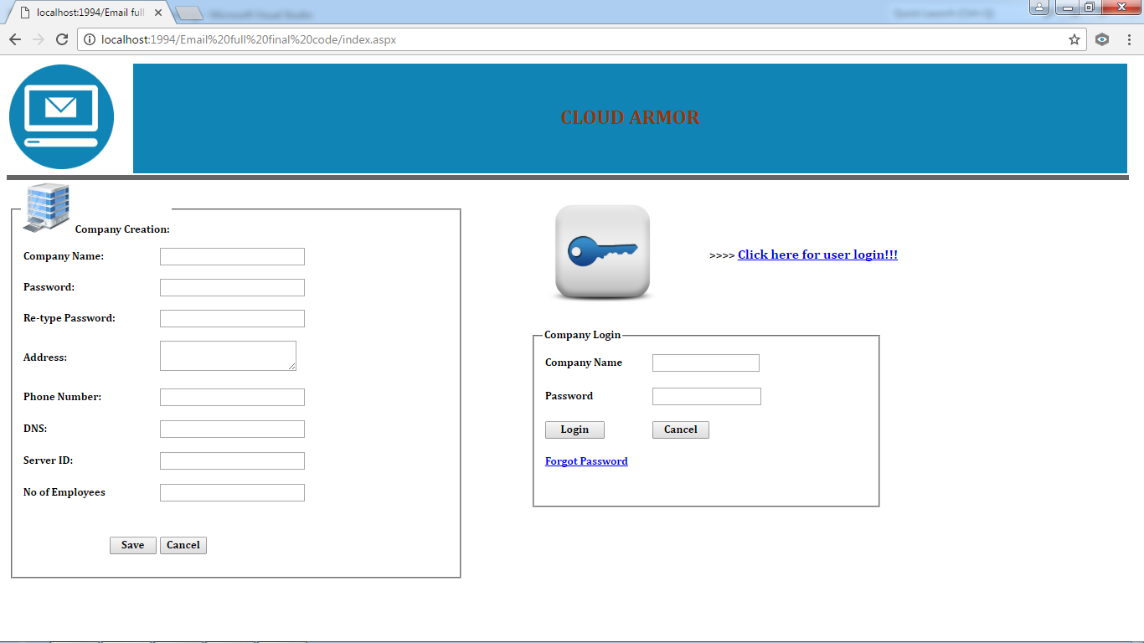

COMPANY CREATION WITH DATA:
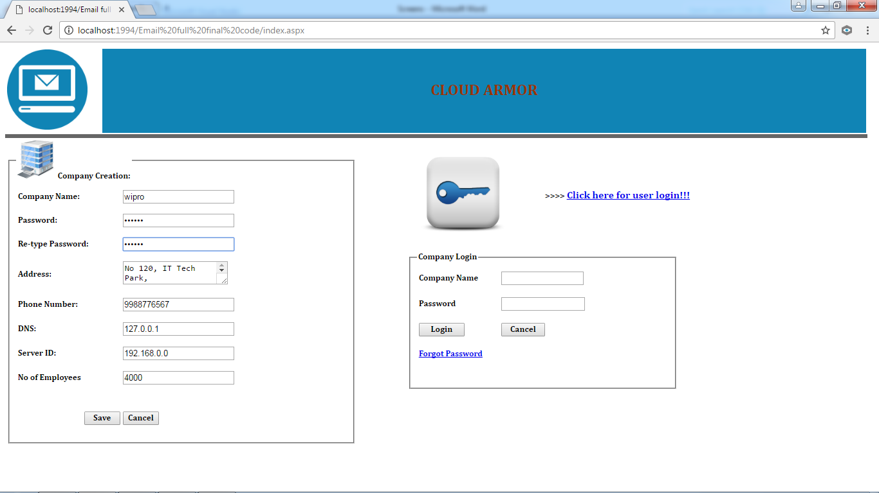

COMPANY CREATED ACKNOWLEDMENT:

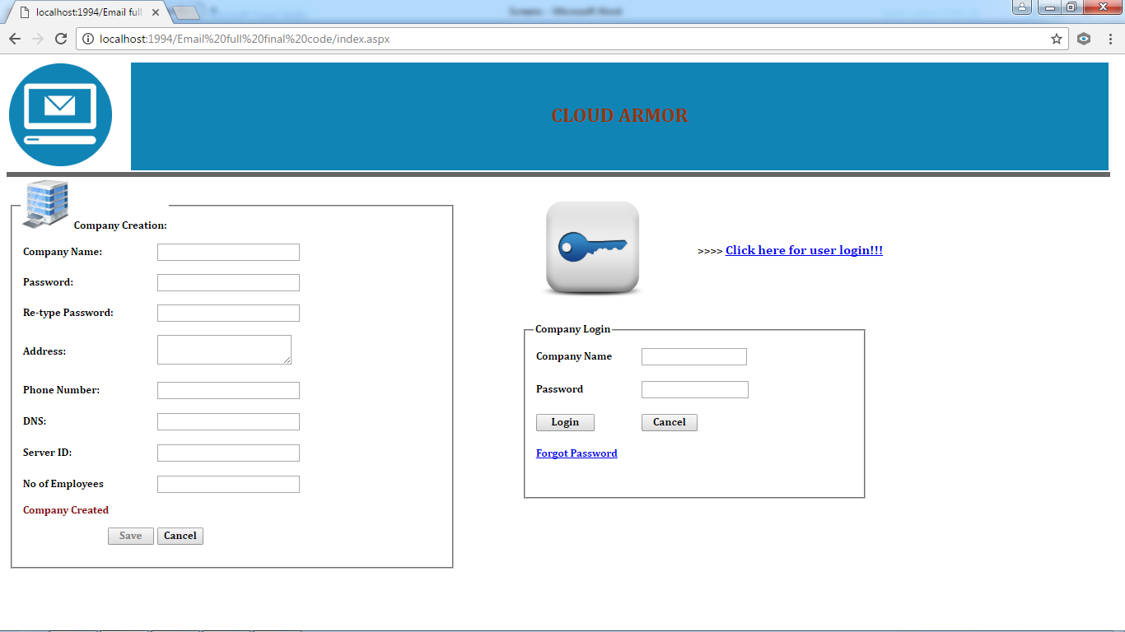

COMPANY LOGIN WITH INVALID USERNAME AND PASSWORD:

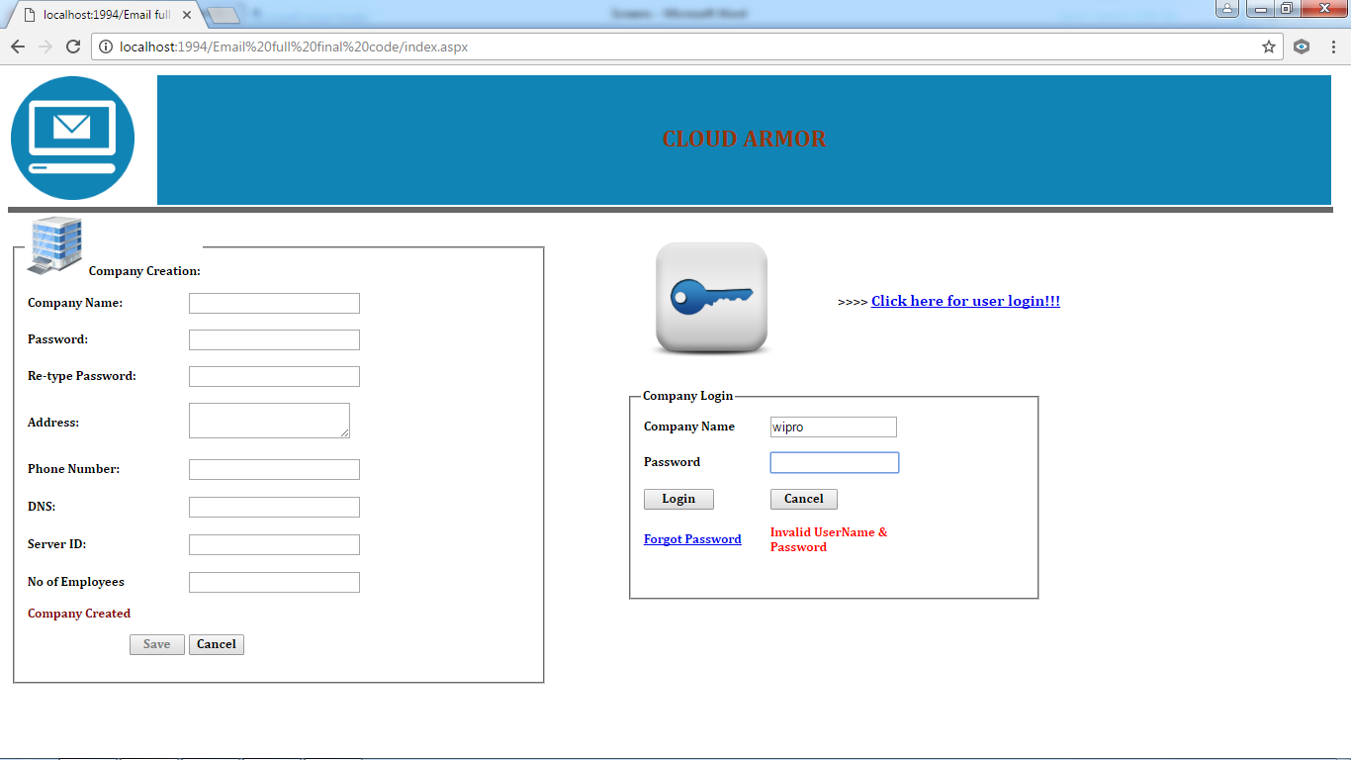

HACKERS ATTACKED ACKNOWLEDGEMENT:

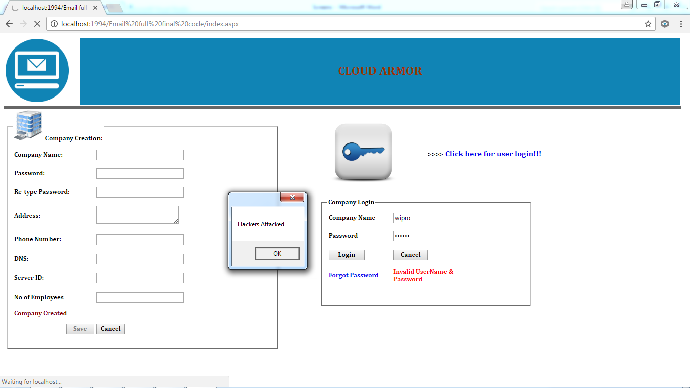

COMPANY HOME PAGE:

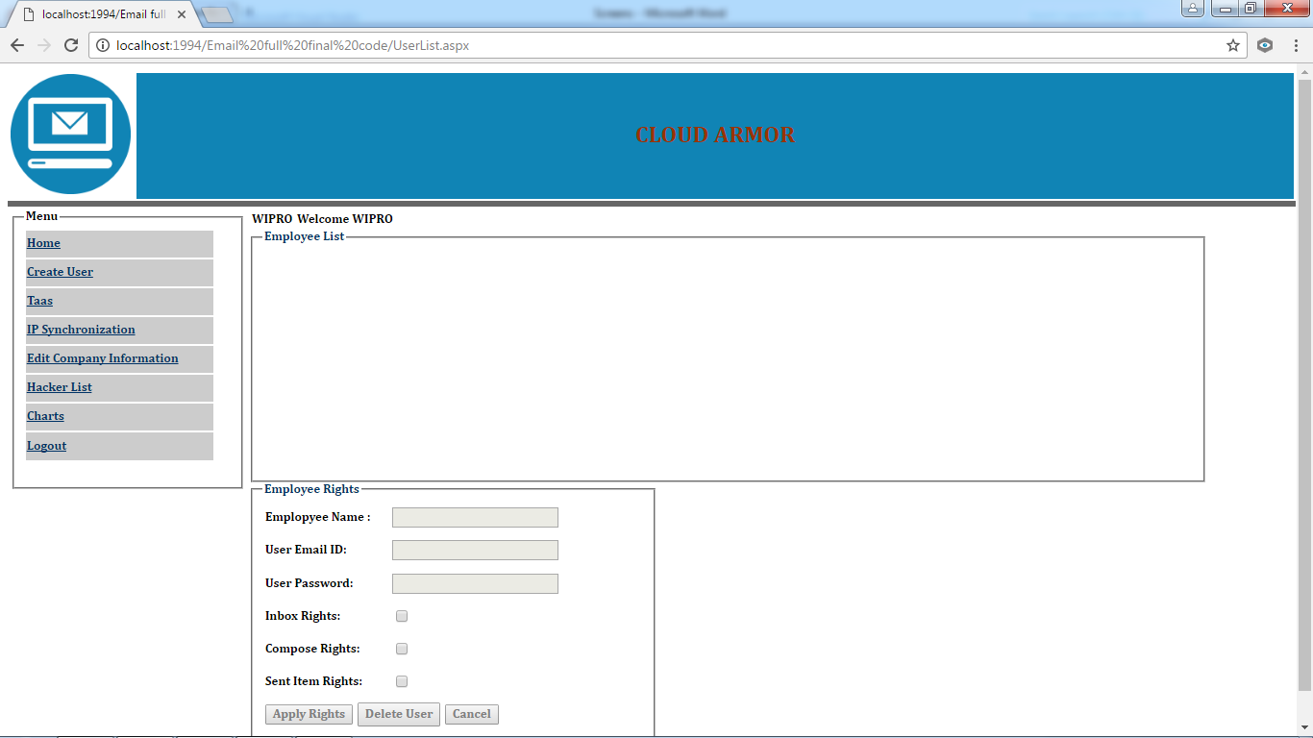

CREATE EMPLOYEE PAGE WITH THEIR DETAILS:

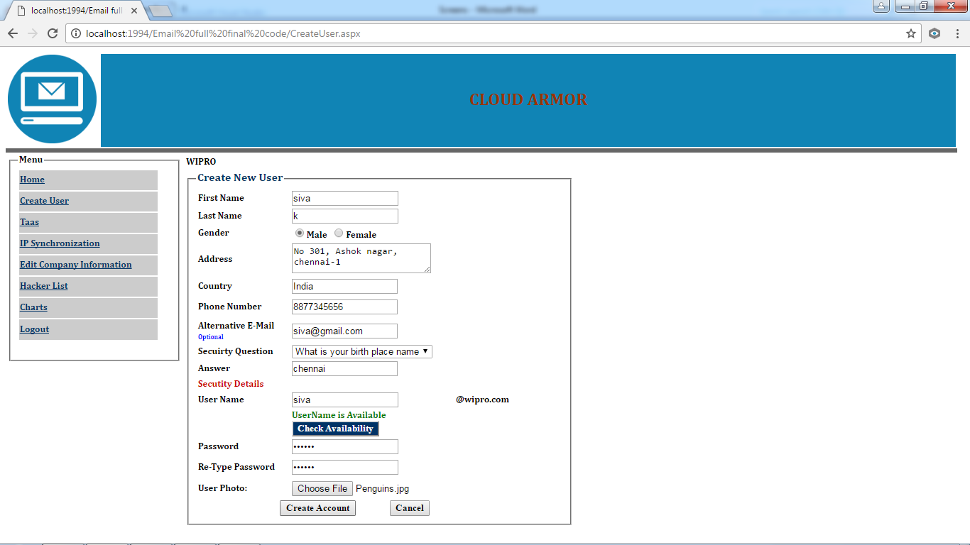

AVAILABLE USER LIST:

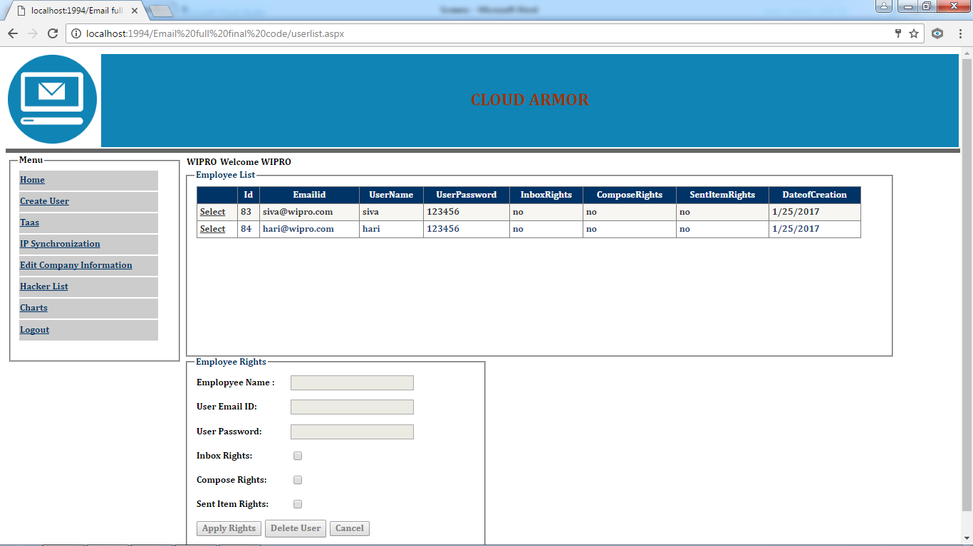

APPLYING RIGHTS FOR THE USER WITH ACKNOWLEDGEMENT:

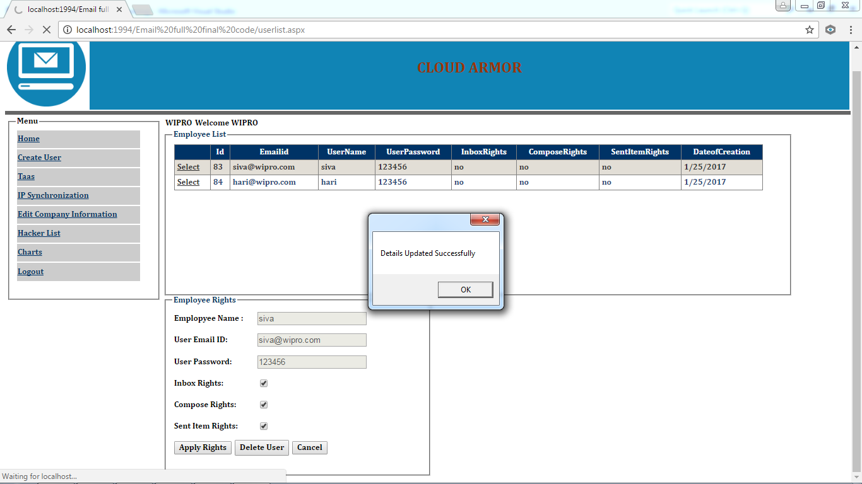

TRUST AS A SERVICE PAGE:
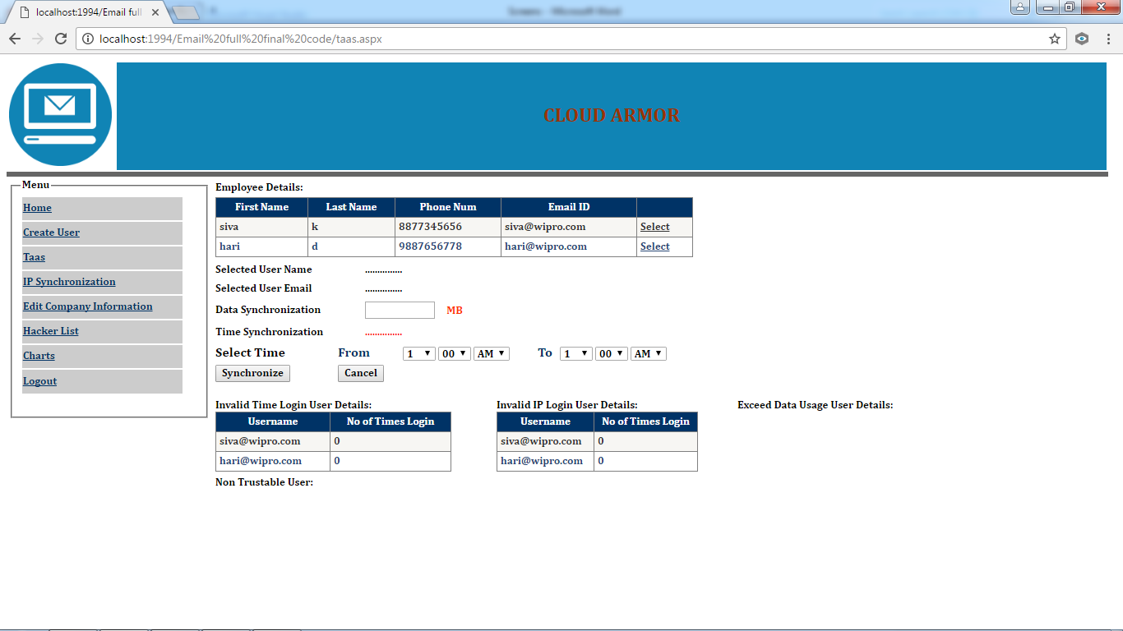

CHAPTER 5

5.1 CONCLUSION:

This project has been implemented successfully according to the committed abstract and all outputs have been verified. All the outputs are generating according to the given input. Data validations are done according to the user and admin input data. The employee’s user name and password are generated in admin login, all the login has been verified successfully.
Trust routing and aware routing framework has been implemented successfully and result has been verified. Both routing frameworks are working according to the expected level. ‘TaaS’ is working well for the 3 types of synchronization methods. And finally untrusted users can be finding out easily using the above mention methods. So dual level security has been provided to the centralized server
Thus cloud armor has been implemented successfully and in efficient manner.

5.2 FUTURE WORK:

Even though the system has been developed in efficient manner, due to time constraints here by we gave some provisions for future enhancements. All the database design is created according to the future work. And all provisions are made in this application according to the future enhancement
The best suit for future work in Green Computing; this is because, now the architecture is developed in cloud environment and it performing well. The next to cloud architecture is green computing which makes the system more powerful and efficient.

ENHANCEMENTS TO BE MADE:
MOBILE RESPONSIVE:
In future this application can be made as mobile responsive application. This makes the admin to handle all the features in a single mobile device or in a tablet.
ENHANCE SECURITY:
Security can be improved by adding, superior security methods like biometric or Voice security for admin. This makes the admin zone more secured.
DATA WAREHOUSE:
Storage server can be improved; the current and existing projects can be stored in the centralized server. This makes the developer to refer with the existing code for code reusability methods.
OFFLINE ARCHITECTURE:
In case of non availability of internet, all these options can be operated in internal LAN architecture. All the data transfer can be made in offline also.
PERFORMANCE:
In case if implementing this application in green computing architecture, the performance can be improved. This makes more data transaction at a same time.

REFERENCES
[1] A. Wood and J. Stankovic, “Denial of service in sensor networks,”Computer, vol. 35, no. 10, pp. 54–62, Oct 2002.
[2] M. Jain and H. Kandwal, “A survey on complex wormhole attackin wireless ad hoc networks,” in Proceedings of International Con-ference on Advances in Computing, Control, and Telecommunication Technologies (ACT ’09), 28-29 2009, pp. 555 –558.
[3] I. Krontiris, T. Giannetsos, and T. Dimitriou, “Launching a sink-hole attack in wireless sensor networks; the intruder side,” in Proceedings of IEEE International Conference on Wireless and Mobile Computing, Networking and Communications(WIMOB ’08), 12-14 2008, pp. 526 –531.
[4] L. Bai, F. Ferrese, K. Ploskina, and S. Biswas, “Performance analy-sis of mobile agent-based wireless sensor network,” in Proceedings of the 8th International Conference on Reliability, Maintainability and Safety (ICRMS 2009), 20-24 2009, pp. 16 –19.
[5] A. Perrig, R. Szewczyk, W. Wen, D. Culler, and J. Tygar, “SPINS: Security protocols for sensor networks,” Wireless Networks Journal (WINET), vol. 8, no. 5, pp. 521–534, Sep. 2002.
[6] R. Watro, D. Kong, S. Cuti, C. Gardiner, C. Lynn, and P. Kruus, “Tinypk: securing sensor networks with public key technology,” in Proceedings of the 2nd ACM workshop on Security of ad hoc and sensor networks (SASN ’04). New York, NY, USA: ACM, 2004, pp. 59–64.
[7] A. Liu and P. Ning, “Tinyecc: A configurable library for elliptic curve cryptography in wireless sensor networks,” in Proceedings of the 7th international conference on Information processing in sensor networks (IPSN ’08). IEEE Computer Society, 2008, pp. 245–256.
[8] I. F. Akyildiz, W. Su, Y. Sankarasubramaniam, and E. Cayirci, “A survey on sensor networks,” IEEE Communications Magazine, vol. 40, no. 8, pp. 102–114, Aug. 2002.
[9] T. Zahariadis, H. Leligou, P. Karkazis, P. Trakadas, I. Papaefs-tathiou, C. Vangelatos, and L. Besson, “Design and implementa-tion of a trust-aware routing protocol for large wsns,” International Journal of Network Security & Its Applications (IJNSA), vol. 2, no. 3,Jul. 2010.
[10] A. Rezgui and M. Eltoweissy, “Tarp: A trust-aware routing protocol for sensor-actuator networks,” in IEEE Internatonal Conference on Mobile Adhoc and Sensor Systems (MASS 2007), 8-11 2007.
[11] S. Chang, S. Shieh, W. Lin, and C. Hsieh, “An efficient broadcast authentication scheme in wireless sensor networks,” in Proceedings of the 2006 ACM Symposium on Information, computer and communications security (ASIACCS ’06). New York, NY, USA: ACM, 2006, pp. 311–320.
[12] S. Ganeriwal, L. Balzano, and M. Srivastava, “Reputation-based framework for high integrity sensor networks,” ACM Trans. Sen. Netw., 2008.
[13] G. Zhan, W. Shi, and J. Deng, “Poster abstract: Sensortrust - a re-silient trust model for wsns,” in Proceedings of the 7th International Conference on Embedded Networked Sensor Systems (SenSys’09), 2009.
[14] O. Gnawali, R. Fonseca, K. Jamieson, D. Moss, and P. Levis, “Collection tree protocol,” in Proceedings of the 7th ACM Conference on Embedded Networked Sensor Systems (SenSys ’09). New York, NY, USA: ACM, 2009, pp. 1–14.
[15] G. Zhan, W. Shi, and J. Deng, “Design, implementation and evaluation of tarf: A trust-aware routing framework for dynamic wsns,” http://mine.cs.wayne.edu/guoxing/tarf.pdf, Wayne State University, Tech. Rep. MISTTR2010-003, Oct. 2010.
[16] X. Hong, M. Gerla, G. Pei, and C. Chiang, “A group mobility model for ad hoc wireless networks,” in Proceedings of the 2nd ACM International Workshop on Modeling, Analysis and Simulation of Wireless and Mobile Systems (MSWiM ’99). New York, NY, USA: ACM, 1999, pp. 53–60.
[17] “Motelab,” http://motelab.eecs.harvard.edu, 2005.
[18] Z. Cao, J. Hu, Z. Chen, M. Xu, and X. Zhou, “Fbsr: feedback-based secure routing protocol for wireless sensor networks,” International Journal of Pervasive Computing and Communications, 2008.
[19] T. Ghosh, N. Pissinou, and K. Makki, “Collaborative trust-based secure routing against colluding malicious nodes in multi-hop adhoc networks,” in Local Computer Networks, 2004. 29th Annual IEEE International Conference on, Nov. 2004, pp. 224 – 231.

